2021

Annual General Meeting

of the

Sea Kayak Association of BC

(SKABC)

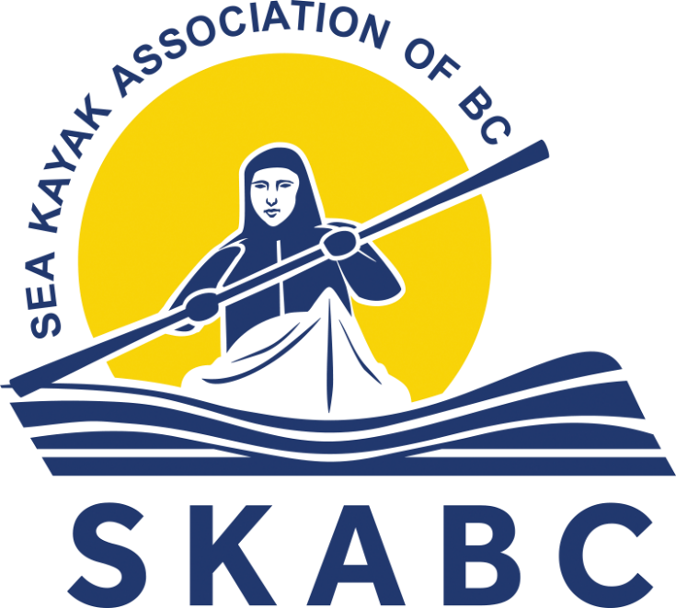

Table of Contents

Agenda for the SKABC Annual General Meeting 3
Executive Committee Annual Reports 6
President’s Report 6
Financial Report 8
Budget Report 9
Balance Sheet 11
Income Statement 12
Communications Report 13
Conservation Report 13
Library Report 13
Membership Report 14
Programmes Report 15
Safety Report 16
Social Committee Report 17
Training Report 17
Trips Report 18
Webmaster’s Report 20
Howe Sound Marine Trail Stewardship Report 20
Outreach & Promotions Report 21
Social Media Report 22
Report from Member at Large 23

Agenda for the SKABC Annual General Meeting

Monday, November 1, 2021.
SKABC’s 2021 AGM will be a virtual meeting held using the Zoom platform. It will be open to SKABC members only in order to facilitate voting. Pre-registration is required using a link, which will be emailed to all members. In order to be able to cast a vote, each member must pre-register personally. After pre-registering, members will be emailed a personal Zoom link prior the meeting.
Zoom log-in will open at 7:00 PM. Please log in with your first & last names. The AGM will start promptly at 7:30 PM.
Agenda
- Verify quorum (10% of the voting membership)
- Adopt the agenda of this meeting.
- Adopt the minutes of the 2020 Annual General Meeting.
- Report of Treasurer and adoption of the 2020 -21 Financial Statements.
- Executive Committee reports.
- Silver Paddle and Orca Awards.
- Election of Directors and other Executive members.
A nominating committee has developed a list of nominees. The current list is presented here but all positions are open for additional nominations from the floor. Positions may be held by one or more individuals. A secret ballot may be requested.
  - Nominations for the Board of Directors:
    - President: George Prevost
    - Vice President: John Leung
    - Secretary: Philip Kubik
    - Treasurer: Nick Heath
    - Training Officer: Chantal Ethier
    - Programs Officer: Kevin Hall
    - Member of the Conservation Committee: Deb Merchant
    - Howe Sound Site Steward: Steve Best
    - Webmaster: Susan Jensen
  - Nominations for the remaining positions on the Executive:
    - Assistant treasurer: Mary Yee
    - Member of the Membership Committee: Enoth Hei Ho
    - Member of the Conservation Committee: Kapila Jayaweera
    - Outreach & Promotions Officer: Clark Perry-Bater
    - Librarian: Lorraine Sharpsteen
    - Member of the Social Committee: Jayne Hardy
    - Member of the Social Committee: Alice Wong
    - Member of the Social Committee: Quirine Schuyff
    - Member of the Social Committee: Darlene Brown
    - Social Media Officer: Mike McHolm
    - Member at Large: Sue Johnson
    - Past President: Chantal Ethier (not open for further nomination)
  - Executive positions with no nominees:
    - Communications Officer
    - Member of the Membership Committee
    - Members of the Trips Committee (two)
    - Safety Officer
    - Workshop Coordinator (new position)
    - Outreach and Promotions Assistant
- New Business
  - Club dues for 2022
- Next Annual General Meeting
Date and location to be determined.
- Adjournment

Executive Committee Annual Reports

President’s Report
George Prevost, President
2020-2021 was again a year of challenges and changes as the Covid pandemic continued to disrupt many areas of our lives. For the club, it meant cancelling some activities, modifying others, and coming up with some new ones.
We were able to continue to have monthly meetings of our members, although these had to be done virtually using Zoom rather than in person. We had a number of excellent presentations, and Zoom’s breakout room function provided an effective way for members to chat and get to know each other in small groups before and after each meeting. Although some members missed the social aspect of in-person meetings, many have said that they preferred meeting virtually. One advantage was that we were able to welcome participants from places as far away as Alberta and Oregon, at least one of whom has now joined our club. The directors have decided that the monthly members’ meetings will continue to be held virtually until further notice.
Our three virtual film festivals, featuring films from the Waterwalker 2020 lineup, were a highlight of the winter season. Each free festival was attended by about fifty people who were able to enjoy a wide variety of different “paddling” films as well as take part in some interesting conversations with other attendees. Plans are underway to have more festivals over the coming winter using films from Waterwalker 2021.
With large social gatherings off the table for most of the year we had to cancel our Christmas party and the annual Spring Fling. However, after some relaxation of the rules we were able to recently hold a very successful Fall Fling which was attended by close to fifty people. Free pizza and salads, as well as lots of great conversation, were enjoyed by all, and many also participated in the five day-paddles that were offered before the picnic.
Because of the uncertainty around rules for gatherings, etc. fewer trips than usual were posted this year and some of those had to be cancelled this spring. However, things returned closer to normal during the latter part of the summer and this fall with a trip roughly every two weeks. Our course offerings were also more limited this year, but several of the more important ones went ahead as usual, including one Beginners’ Course, the Trip Leaders’ Course, the Currents Course and two courses focused on boat handling and stroke improvement. Several half-day clinics were also offered, including two on boat handling, two on rescue practice, and one on boat packing and trip planning.
Less affected by the pandemic was our ongoing work to improve the overnight camping infrastructure in our local area, especially in Howe Sound, where a number of significant improvements were made to the six BC Marine Trails sites that we are providing stewardship for. We have also begun work on a campsite at Apodaca Park on Bowen Island and one of our members has generously offered use of part of her property on Gambier to other is in the club. Thanks to Nick Heath and Steve Best for spearheading this work.
In terms of administration, Nick Heath, our treasurer, and Mary Yee, his helper, and I worked hard to reorganize our somewhat complicated financial information so that it is easier to see how much money we have, where it is coming from and where it is being spent. Although all of our money is in one bank account, we have notionally separated it into four separate categories and are now accounting for each separately. The first is our “operating account” where we are keeping track of all of our day-to-day business: income from membership and course fees and expenses for insurance, administration, courses, social events and so on. Income and expenses in this account are budgeted to balance over the course of each fiscal year. The second is our “special projects account”. Here we are keeping track of income from grants received for projects such as our ongoing Howe Sound stewardship, of transfers from the operating account and our legacy fund (see below) for such projects, and of the money spent on these projects. Again, income and expenses are budgeted to be in balance each year. The third category is our “reserve fund” where a portion of past surpluses has been accumulated to create a rainy-day cushion of about a year’s basic operating costs. Finally, we have our “legacy fund” where money from a number of sources has accumulated over most of the life of the club. The intention is for this money to be spent over the next few years on projects that will leave a lasting legacy for club members and paddlers in general. Improvements to the BC Marine Trails sites in Howe Sound are a good example.
We have also made an effort this year to conduct our affairs in a more formal, businesslike manner than may sometimes have been the case in the past. Each decision that we made, or considered making, was first presented in the form of a motion which, after discussion and possible amendments, was formally voted on. Philip Kubik, our secretary, has been an important part of this process, providing us with clear, detailed agendas for our meetings and keeping detailed, accurate records of the proceedings.
We are looking forward to an excellent year to come. Our Programs chair, Kevin Hall, already has a number of excellent presenters lined up for our upcoming monthly meetings. And we hope to provide more opportunities for in-person socializing by combining short workshops and/or local paddling trips with picnic style get-togethers on the same weekend day, somewhat like our recent Fall Fling, but probably on a smaller scale. Plans are also underway to have more virtual film festivals over the coming winter using films from Waterwalker 2021. And, last but definitely not least, we are well-positioned to resume a full slate of courses and trips. For trips, in particular, we intend to work hard to get more members involved as leaders so that we can offer more opportunities for people to paddle together with other club members.
I’d like to finish by thanking all of the executive for their excellent work this year. It’s been a privilege to lead such a strong, committed team of talented people!

Financial Report
Nick Heath, Treasurer

Fund Re-structuring
This was another unusual year, but our finances are in good shape.
We re-structured our accounting somewhat to make things clearer and to separate our year by year operating funds and budgets from the spending of previously accumulated funds and grants. SKABC now has four notional accounts:
- Operating Fund
- Legacy Fund
- Special Projects Fund
- Reserve Fund
In addition, instead of our funds simply rolling forward each year, we now formally transfer any Operating Fund surplus at year end into the Legacy Fund. A separate Reserve Fund of $6,500 should take care of potential annual operating deficits and unforeseen needs. Note that the Income Statement reflects only the Operating Fund, our day-to-day account.

Grants
This year we have been very successful in asking for and receiving grants to help with some of our projects, thereby conserving other funds – frugality reigns! Here is a list of the grants.

Source of Grant | Purpose | Amount
2020 Park Enhancement Fund BC Parks | Apodaca Park access and loop trail | $3,000.00
RSTBC site maintenance grant | Taking care of 6 Howe Snd. rec. sites | $5,000.00
Squamish-Lillooet Regional District | Zorro Bay tent platforms | $10,000.00
Outdoor Recreation Council of BC | Trails Day Prizes | $302.71
Valhalla Pure Outfitters Squamish Trail Fund | Tent platforms: Islet View & Tantalus Ldg. | $9000.00
BC Marine Trails Network Assn | Public donations for Howe Sd | $500.00
2021 Park Enhancement Fund BC Parks | Apodaca Park tent platforms | $5,000.00*
* The 2021 Park Enhancement Fund grant for Apodaca Park tent platforms has been promised but not yet received.
Steve Best, Deb Merchant and Nick Heath all worked energetically to secure these grants. Thank you!
Mary Yee again provided excellent assistance with her careful record-keeping and reconciliation of bank statements. Extra work was needed to re-align our accounts and funds.

Expenditures of Legacy Funds
We continued to carefully spend some of our accumulated savings – the Legacy Fund - on long -term investments in the local paddling area. Many of this year’s expenditures were made from the previous year’s allocation of some $25,000 of the Legacy Fund into a Special Projects Fund. An accompanying budget spreadsheet gives the details.
Suggestions from members for the appropriate use of Legacy Funds are always welcome.

Budget Report
OPERATING FUND
Revenue | Responsible Exec. member | Budget | Goals, notes | Revenue | %
Membership Dues | Walter/Enoth | $ 8,000 |  | $ 8,655 | 108%
Training | Chantal/Katya | $ 7,000 | Aim to break even | $ 1,860 | 27%
Merchandise Sales | Clark/Susan | $ 250 |  | $ - | 0%
Film Fest | Clark | $ - |  | $ 113
Legacy fund interest | Nick | $ 1,500 |  | $ 1,875 | 125%
Other Income (misc.) | Nick | $ 150 |  | $ -
Trips deposits | Allan/Mike | $ 900 | Aim to break even | $ 360
Total revenue |  | $ 16,300 |  | $ 12,863 | 79%
Expense |  |  |  | Expense | Item Balance
Administration | George | $ 3,500 |  | $ 3,576 | -$ 76
Capital Purchases | George | $ - |  | $ - | $ -
Conservation, Parks & Marine Trails | Deb/Kapila | $ 500 | Events, memberships | $ 296 | $ 204
Donations Expense | George | $ - |  | $ - | $ -
Outreach/marketing & Film Festival | Clark | $ 500 |  | $ 201 | $ 299
Howe Sd Site Stewardship | Steve | $ 4,500 |  | $ 1,927 | $ 2,573
Library | Lorraine | $ 150 |  | $ 68 | $ 82
Membership | Walter/Enoth | $ 250 |  | $ - | $ 250
Merchandise Cost | Clark/Susan | $ - |  | $ - | $ -
Programs | Kevin | $ 750 |  | $ 600 | $ 150
Social Committee | Darlene | $ 500 | Some events cancelled by PHO | $ 550 | -$ 50
Training | Chantal/Katya | $ 8,000 | Aim to break even | $ 1,262 | $ 6,738
Trips | Allan/Mike | $ 900 | Aim to break even | $ 381 | $ 519
Total Expense |  | $ 19,550 |  | $ 8,861 | $ 10,689
OPERATING ACCOUNT SURPLUS (DEFICIT) |  | -$ 3,250 |  | $ 4,002

LEGACY FUND
 |  |  |  | Activity | Balance
Starting balance on 2020-10-01 |  |  |  | $ - | $ 69,453
Operating surplus from FYE 2019-20 |  |  |  | $ 21,903 | $ 91,356
Transfer to Special Projects - Howe Sound improvements |  |  |  | -$ 25,000 | $ 66,356
Contribution to purchase W Ballenas I |  |  |  | -$ 1,000 | $ 65,356
Transfer to Special Projects - Stove replacement at member cabin |  |  |  | -$ 750 | $ 64,606
Contribution to purchase Young Pt, Lasqueti I |  |  |  | -$ 1,000 | $ 63,606
Balance on 2021-09-30 |  |  |  |  | $ 63,606

SPECIAL PROJECTS FUND
Source | Project | Revenue | Description | Expense | Balance
Transfer from Legacy Fund | Howe Sound improvements | $ 25,000 | Toilet Thornbrough Ch - completed | $ 9,749 | $ 15,251
 |  | $ - | Toilet Ramillies Ch - completed | $ 8,237 | $ 7,014
 |  | $ - | Footbridge Thornbrough Ch - completed | $ 2,775 | $ 4,239
Transfer from Legacy Fund | Stove replacement at member cabin | $ 750 | Delivered to site - in progress | $ 750 | $ 4,239
BC Parks: Park Enhancement Fund | Apodaca Park trail | $ 3,000 | Access up bank, loop trails - completed | $ 3,248 | $ 3,991
Howe Sound Stewardship RSTBC Grant | General maintenance, site work | $ 5,000 | Funds not yet allocated | $ - | $ 8,991
SLRD Zorro Bay site improvement grant | Zorro Bay platforms | $ 10,000 | 3 tent platforms, table - completed | $ 9,717 | $ 9,274
Squamish Trail Fund Valhalla Pure Outfitters | Tent platforms | $ 9,000 | Materials on site Tantalus Ldg. & Islet View -in progress | $ 9,500 | $ 9,274
Public Howe Sd. donations via BCMT |  | $ 500
ORC Trails Day Grant | Prizes | $ 303 | Completed | $ 303 | $ 9,274
Totals |  | $ 53,553 |  | $ 44,279 | $ 9,274

RESERVE FUND
Starting balance on 2020-10-01 |  |  |  | $ - | $ 6,554
Expense (none) |  |  |  | $ - | $ 6,554
Balance on 2021-09-30 |  |  |  | $ - | $ 6,554
VCCU MEMBER SHARES |  |  |  |  | $ 384
CURRENT TOTAL FOR ALL ACCOUNTS/FUNDS* |  |  |  |  | $ 83,820
* Matches balance sheet if prepaid 2021/22 expenses added. |  |  |  |  | $ 179

Balance Sheet
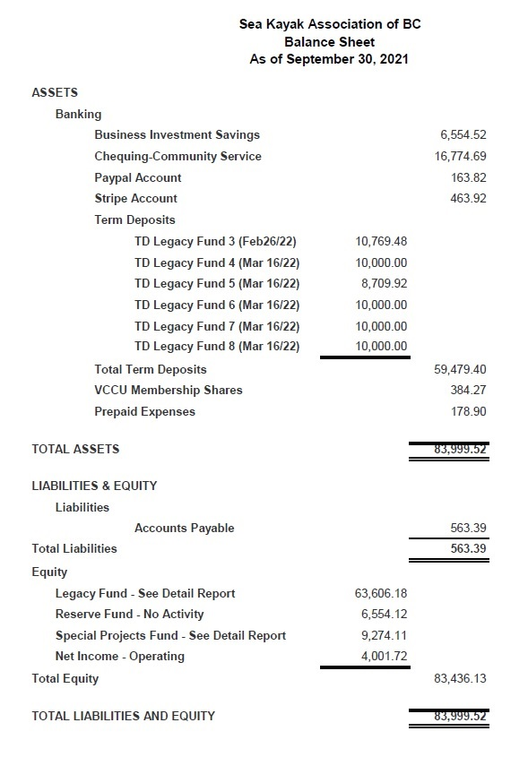

Income Statement
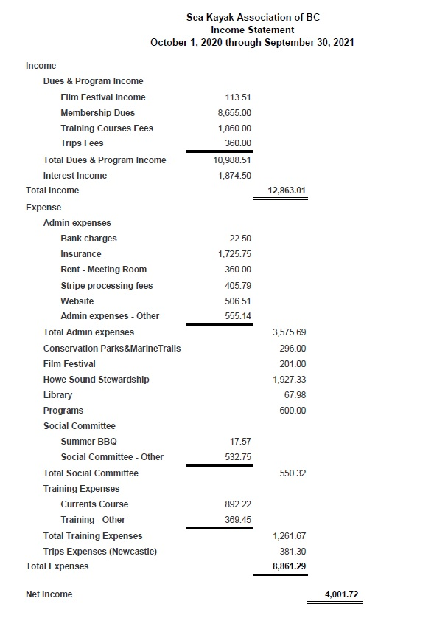

Communications Report
Nick Jones, Communications Officer
Club emails continue to be one of the primary methods of communication with members (along with the website, social media and events).
During the Summer months we experimented with doing both a regular monthly and mid-month email to members. This turned out to be a bit onerous and perhaps was overkill with regard to communicating with members. Starting in the Fall we switched back to monthly newsletters.
A new approach for authoring the monthly newsletters was tried this year with some success. This involved creating a draft newsletter one week in advance of the publishing date and sharing it with the executive committee for review and improvement. Throughout the week improved versions were shared with the executive committee until it reached a final state ready for publishing to the members.
In general, monthly newsletter emails were sent to members one week in advance of upcoming monthly meetings.
Throughout the year ad-hoc emails were also sent as requested by various different club committees.

Conservation Report
Deb Merchant and Kapila Jayaweera, Conservation Committee
Conservation activities continued to be affected by COVID this year. It has been a year of planning and hoping.
Invasive plant removal projects in Belcarra (Apr 24, 2021 & May 5, 2021) in partnership with Metro Vancouver Regional Parks were posted and then cancelled due to COVID-19 restrictions. Widgeon Creek was not an option this year. We look forward to more trips in the future. June 8 was World Oceans Day and no events were allowed in Vancouver or Burnaby.
We lent a hand to other projects as possible including clean-up of Bain Creek recreation site and Apodaca Park and fundraising for West Ballenas Island.
Online events were more successful. We participated in the new BC Marine Trails Cross-Club Group to share info between clubs. Finally, we held a trivia contest/movie night (June 11, 2021) to support the Outdoor Recreation Council’s first BC Trails Day.

Library Report
Lorraine Sharpsteen, Librarian
The SKABC library consists of books and DVDs covering the following topics:
Where to:
• Kayaking destinations (guidebooks and histories)
• Charts
How to:
• Cooking
• Strokes/surfing
• Wilderness etiquette
• Repairs
• Fishing
• Wildlife
• Weather
• Navigation
Travelogs
Currently our physical collection totals 79 books and 19 DVDs, housed in three plastic bins and stored at my home. In addition, 44 items remain outstanding (43 books, 1 DVD). They were checked out by members and have not yet been returned. Of these items (both in our physical collection and overdues), 26 are guidebooks more than 10 years old.
Plans for the coming year: replace out-of-date guidebooks, contact members about overdue items (those not out-of-date), and upload the entire catalogue onto the website. Replacing 26 guidebooks at an average cost of $25.00/book will require approximately $700.00.
Members are encouraged to email Lorraine at library3@skabc.org with titles of books and DVDs they would like to see in our collection.

Membership Report
Enoth Li, Membership Committee
Our membership is at 205. The numbers are not dropping as fast as previous years. Our numbers for the past few years are shown below.
- 205 - 2021
- 207 - 2020
- 247 - 2019
- 269 - 2018
- 255 - 2017
- 225 – 2016

Programmes Report
Kevin Hall, Programmes Officer
It’s been a year of adjustment to conditions outside our control and to trying new things. In spite of not having any in-person monthly meetings, the club was able to run ten meetings by Zoom with a total of twelve presenters! We created a survey in July and 73 members took the time to share their thoughts on a wide range of topics from the quality of presentations, breakout rooms, future presentation topics and their preference for virtual or in-person meetings. The results were very helpful and encouraging: 61 responders attended one or more virtual monthly meeting, some attended all, and the presentations were enjoyed almost universally.
Regarding the meeting format, there is a strong preference to keep the presentations virtual although a small number of members still would like to see a return to in-person meetings. The convenience of the virtual meetings was mentioned several times and the breakout rooms provide a new and interesting social experience that many members look forward to and prefer to Sunrise Hall. Many responders requested additional in-person activities aside from the regular monthly presentations and the executive is actively looking to add these to our calendar and continue with the virtual monthly meetings.
The many comments and suggestions for presentation topics will guide the selection of presenters for the coming year and also in-person skill sessions. Overall, the responses were very positive and supportive of the efforts made and the presentations provided.
Here is a record of the presentations for the past year:
December: Club slideshow by Allan Edwin followed by a presentation by SISKA member, Elizabeth Purdon, on her trip with Freya Hoffmeister in Baja, Mexico.
January: Jackie Hildering presented “Return of Giants” about her research and experience with Humpback whales in local waters.
February: JF Marleau gave a slideshow featuring his many trips to Antarctica and South Georgia
March: Dave Scott from Raincoast Conservation spoke about the research and efforts being done to preserve the lower Fraser estuary
April: Debbie Leach shared the work being done to collect accommodation details on their Kayak Friendly lodging website. Followed by a slideshow and commentary by George Prevost showing images from his trip down the Stikine River – a last minute, and much appreciated, presentation after our feature presenter had to reschedule.
May: Angela Burns and Bill Atherholt from Fishing for Plastic shared the work they’re doing both locally and in the Bahamas. Followed by a presentation by Vanessa Isnardy from Wildsafe BC on bear safety in the back country.
June: Norm Hann presented a slideshow with commentary of his paddleboard trip following the Salish Sea Marine Trail
July & August: Two picnics in lieu of meetings.
September: Leif Sverre of Island Expeditions shared information about their kayak tours and operations in Belize
October: Dan Lewis, stories from when he started paddling in 1978 through to his efforts to conserve Clayoquot Sound
November: AGM followed by a Howe Sound Marine Trail site update by Steve Best
Upcoming presentations:
December: Christmas Party and/or Film Night (TBD)
January: Ross MacDonald, Environment Canada Meteorologist to discuss marine weather forecasting for paddlers
February: Frank Wolf, adventurer, shares stories and pictures from one of his recent paddling expeditions
March: Mikele D’Arcangelo of ACR Electronics, makes of ResQLink Personal Locator Beacons and safety equipment

Safety Report
Scott Tebutt, Safety Officer
Well, it was great to see a few more trips and events take place this year, culminating in the most excellent Fall Fling. No safety issues have arisen (or at least been reported), and I hope everyone has managed to get fully vaccinated in preparation for the next phase of this quite crazy time in our history. In part inspired by Mike Gilbert, several club members did set up rescue practice sessions during the summer season, and these went very well. Venues included Crescent Beach in Surrey and Eagle Harbour in West Vancouver, both of which worked nicely for half-day sessions to run through self- and assisted rescues, as well as enabling participants to become just a little bit more (but not too) comfortable being upside down under water! Safe paddling and adventures to all!

Social Committee Report
Darlene Brown, Social Committee member
Social gatherings were on hold due to COVID-19 restrictions for the first half of the year. From July to September the following events went ahead:
- An evening picnic at Locarno Beach, Vancouver on July 5. It was a bring-your-own-food-and-utensils-meal with 21 attendees. The weather was lovely for a beach reunion, conversation and turns at the Jensen’s corn-hole game.
- Another evening picnic at Locarno Beach, August 9. Food to share was an option for this event and some did so. We had a different toss game while most people relaxed with each other’s company. Attendance was consistent at about 20.
- In the absence of our traditional Spring Fling, the executive chose to hold a Fall Fling. After further thought we combined the Fling with our traditional Volunteer Appreciation Dinner as the dates would have been so close and a venue was difficult to come by. We held the combined events September 25 at our reserved picnic shelter at Cates Park, North Vancouver, close to where paddlers came in from their day trips. Luckily the weather was very much on our side. The Club provided the food for this event, with pizza and salads the main course for 44 attendees. There were many comments of appreciation from attendees after Steve Best’s engaging appreciation speech.

Training Report
Chantal Ethier, Training Officer
2021 was still impacted by the pandemic; as such SKABC was unable to offer its full course schedule. Nonetheless, we were able to offer a few. The following courses and clinic took place:
Courses
- 2 Boat Handling & Stroke Improvement (1 day course, Hadden Park Beach)
- 1 Beginners (2 day course, Cates Park)
- 1 Trip Leader (3 day course, Gambier Island)
- 1 Currents (3 day course, Mayne Island)
Clinics
- 1 Strokes clinic (1/2 day, Vanier Park)
- 1 Turning strokes technique & practice (1/2 day, Vanier Park)
- 1 Basic trip planning & kayak packing with half day paddle (1 day, Jericho Beach)
Participation
- Students: 40
- SKABC Instructors: 9
We will be preparing our 2022 schedule as in previous years in the hope of resuming our normal course offering. We will send an invitation to our instructors in due course and post an invitation on the website for anyone who may not have instructed in the past but who may be interested in joining the Training Team.
Stay tuned and stay safe!

Trips Report
Allan Edwin, Trips Officer

Overview
The 2021 season started with a continuation of the overall provincial lock-down from 2020. The phased lifting of intra-provincial travel restrictions, starting in June, allowed for a few events and trips, but many club members made plans for non-paddling activities for the summer. As a club we must focus on posting trips that will develop our advanced beginners and intermediate paddlers towards leading trips for future years.

Trip Planning
Our 2021 season started with some hope. A web survey of club members had 36 respondents indicating their interest in a catalog of trips. Respondents were allowed to 'cast votes' on all the trips they would participate in if available. This allowed us some insight into what trips to target.

 | Count | Total Votes | Top 3
Day Trips | 44 | 456 | Porteau Cove-Zorro Bay (21), Porteau Cove-Islet View (19), Widgeon Creek (19)
Overnight | 40 | 476 | Deer Group/Barkley Sound (22), Broken Group/Barkley Sound (18), S. Gulf Islands - Portland Island (18)
Expedition | 14 | 173 | Port Hardy - Gods Pocket (22), Telegraph Cove - S. Broughton (19), Tofino - Vargas Island (16)
Activity | 11 | 179 | Howe Sound - Camp Cooking Weekend (22), Belcarra Invasive Species (21), Howe Sound Stewardship / Widgeon Creek Stewardship (20)

2021 Activity
Unfortunately, the lockdown restricting travel between regions and within regions was extended through April and May and we were forced to cancel our Spring Fling and early season paddles. Vaccination programs progressed and restrictions began to be lifted in June for some areas and fully in July. Trips scheduled from June through the end of year have been completed - bright spots in a calendar that in other years had twice as many trips scheduled.
Club members join for 2 primary reasons: to paddle more and to find people to paddle with. Each of our departments contributes to these goals from a different aspect. The role of Trips Coordinators is not just to get trips into our calendar, but to get trips posted that encourage the development of our beginner and intermediate paddlers into experienced paddlers that will be able to lead club trips in the future. Club trips are where our members exercise their skills in a safe and fun culture.
For better or worse, our experienced paddlers did get out on the water this year. I know, I saw the photos and videos on social media. Our beginner and intermediate paddlers may have got out on the water, but if they did so, it was likely not through the club. I did encourage visits from club friends up here to Quadra and I was happy to paddle with a few of you. I hope next year to see more of you visiting here.

Trip Start | Trip End | Class | Trip Description | Leader 1 | Leader 2 | Trip Status
2021-03-13 |  | 2B | English Bay | Philip Kubik |  | Cancelled
2021-04-24 |  | 2A | Belcarra Invasive Plants Removal | Deb Merchant |  | Cancelled
2021-05-01 |  | 3C | Anvil Island and Pam Rocks | Philip Kubik |  | Cancelled
2021-05-05 |  | 2A | Belcarra Invasive Plants Removal | Kapila Jayaweera |  | Cancelled
2021-06-12 |  | 2B | White Rock Crabbing Paddle | Susan Jensen |  | Completed
2021-06-28 |  | 2B | Howe Sound with Archaeologist | Brian Pegg |  | Completed
2021-08-01 |  | NA | Blackie Spit, Rescue Practice | Susan Jensen |  | Completed
2021-08-04 | 2021-08-06 | 3B | Gambier Island, Private Cabin | Nick Heath |  | Completed
2021-08-08 |  | NA | Blackie Spit, Introduction to Currents | George Prevost |  | Completed
2021-08-21 |  | NA | Eagle Harbour (Rescue Practice) | Scott Tebbutt |  | Completed
2021-09-03 | 2021-09-06 | NA | Newcastle Island Labor Day Weekend | Allan Edwin |  | Completed
2021-09-25 |  | NA | Fall Fling, Cates Park up Indian Arm | Multiple |  | Completed
2021-09-26 |  | 2C | Ambleside to Eagle Harbour | Philip Kubik |  | Completed
2021-10-08 | 2021-10-11 | 3C | Thanksgiving on Howe Sound | Allan Edwin | Ted Lam | Scheduled
2021-10-16 |  | 2C | English Bay | Philip Kubik |  | Scheduled
2021-11-07 |  | 2B | Belcarra Invasive Plants Removal | Kapila Jayaweera | Deb Merchant | Scheduled
2021-12-06 |  | 2C | Indian Arm, Deep Cove to Silver Falls | Philip Kubik |  | Scheduled

Looking Ahead
The past 2 years of pandemic conditions have made it difficult for us to continue development of our beginner and intermediate paddlers. Ironically, these two years have also seen the largest explosion of interest in outdoor activities in recent memory. It has been exquisitely frustrating for me to see new paddlers asking questions on Facebook instead of in our club meetings, events, and trips.
That said, we must focus on the future. I will be stepping down from the Trips Coordinator role as it is time for someone living in the Lower Mainland, more able to participate in club events to take it on. I am planning to remain a club member in 2022. I plan to post and lead club trips if anyone is ready to come up here. I will continue to encourage those beginner and intermediate paddlers we need to develop a new cohort of trip leaders for our club.

Webmaster’s Report
Susan Jensen, Webmaster
SKABC runs a Wordpress website that includes software to manage event listings, a member database, email notifications, instructor and executive resources and a forum. According to Google Analytics the club averages 35 visitors to the website each day, with members of the club and the public accessing paddling resources and information about club activities.
Starting in 2020, a COVID 19 section has been part of the site. Event reminders emails that are sent through the website were modified to include COVID messaging.
The site is run by a volunteer webmaster and is hosted at GoDaddy. Our host keeps backups of the site which were used to manage some technical challenges that came up this past Spring.

Howe Sound Marine Trail Stewardship Report
Steve Best, Howe Sound Marine Trail Steward

Site Stewards
At the beginning of the year, Site Stewards were recruited for each of the six Recreation Sites:
- Ramillies Channel - Cynthia Kennedy
- Bain Creek - Philip Kubik
- Thornbrough Channel - Kevin Hall
- Islet View - Brian Pegg
- Zorro Bay - Mike McHolm
- Tantalus Landing - Dave Berrisford
Site Stewards have performed site Inspections, replenished wood shavings, and done work on the sites.

SLRD Grant
Tony Rainbow, past Chair and current Councillor with the Squamish Lillooet Regional District Council, contacted us last fall saying, “I am looking for projects that enhance recreational opportunities in the SLRD and that can also provide local employment, so the Marine Trail could be a good fit.” In March, the Council approved a $10,000 grant to be spent on the marine trail site in their regional district, Zorro Bay, on the Sea to Sky Marine Trail.
At the end of August, Thimbleberry Contracting spent two days at Zorro Bay building three tent platforms, a second picnic table, and putting up two signposts.

RSTBC Site Tour
In March, I accompanied four staff from RSTBC on a tour of all six sites. They included the District Recreation Officer, who hadn’t been out to the sites since 2014 or 2015, his assistant, and a danger tree assessor. On the same trip, four giant bags of wood shavings were dropped off at the sites that need them. The shavings had been collected by one of the site stewards who is taking a woodworking course.
Subsequent to the tour, a wildfire crew went to the sites and cut down the danger trees.

Valhalla Squamish Trail Fund Grant
Valhalla Pure Outfitters in Squamish donated $9,000 for tent platforms at two sites. Cedar was milled and on September 13, 2021, it was loaded on a water taxi and volunteers dropped off lumber for three platforms at Tantalus Landing and for two platforms at Islet View. The platforms will be built by volunteers in the Spring.

Apodaca Park
Last February, Nick Heath camped out on site with a contractor, completing an access trail and kayak rack funded by a $3,000 Parks Enhancement Fund grant. Nick has secured another $5,000 Parks Enhancement Fund grant to mill cedar for four tent platforms. The platforms will be built by volunteers once First Nations consultation is complete.

Outreach & Promotions Report
Clark Perry-Bater, Outreach & Promotions Officer
The first priority when I took on the role of Outreach & Promotions Oﬃcer at last year’s AGM was to contact the previous oﬃcer, Calvin Sam, to glean whatever I could from him about projects, priorities, and logistics that he had developed during his years on the job.
The main project was the annual paddling film festival that had been organized for 4 or 5 years running and which had been very successful at promoting the club and bringing in new members, as well as educating and entertaining everyone who attended. Calvin had coordinated with Rapid Media, the titleholders of the World Tour Paddling Film Festival, to have access to their films. There was also the WaterWalker Film Festival, managed by Paddle Canada, whose films we could possibly arrange to show.
A Film Festival Committee was struck to research various possibilities for streaming films and to preview films from both providers. The committee members were George Prevost, Allan Edwin, Kevin Hall, and me. Many thanks to the other members of the committee for their assistance.
After much discussion with the ticketing manager for the Vancouver International Mountain Film Festival regarding various options for showing films online, most of which involved complex streaming logistics, the executive agreed that we would make use of the Rapid Media program, which had an impressive array of films, arranged into three categories: Adventure, Adrenaline and Culture. The festival was organized in such a way that SKABC could sign on as an aﬃliate presenter, promote the festival to club members and friends, and the club would receive a commission from each ticket sold. All films were shown online, on their website, due to restrictions of the Covid-19 pandemic.
At last count, thirty-six Rapid Media festival tickets were sold through our aﬃliate website (at a price of $15 US), which brought in just over $100 US ($125 CDN) for SKABC.
While we were waiting for the cash to roll in from the Rapid Media festival, the committee and the executive agreed that we would show films from the WaterWalker Film Festival to our club members free-of-charge on three Friday evenings as a perk for being members, with online group discussion after each evening to give our festival a more social aspect. After many attempts to contact the WaterWalker technical person, the committee finally got access to their catalogue of films, and we set about previewing and selecting the films to show our membership. For our first festival we paid Hoovie.movie to host. Although the festival was a success, Hoovie’s process proved to be too cumbersome for our purposes so we decided to use a combination of Vimeo and Zoom for the subsequent two festivals and found it worked much better and was considerably cheaper as well. The festivals took place on three Friday evenings in April and May last spring.
With the omnipresent Covid-19 pandemic restricting our in-person gatherings for the last eighteen months, I found it diﬃcult to promote our paddling club, or to think of ways to reach out to other groups to promote the sport of ocean kayaking. The recent Fall Fling and accompanying daytrips, which included 40-50 club members, was, for me, a great reminder of the purpose of being in a paddling club. I anticipate more outreach and more promotion of our club and the sport in the year ahead.

Social Media Report
Mike McHolm, Social Media Officer

Club Goals for Social Media
- Expand club exposure to paddlers and potential new members.
- Disseminate information about events, meetings, trips etc. with consistent brand identity.
- Provide a platform for members to have their club activity media posted online (photos, videos etc.)
- Display our values of sportsmanship, teamwork and community spirit.

Social Media Report
Over the past year I have posted Club Meetings and Events on Facebook, Instagram and Twitter. Our YouTube channel doesn’t get much engagement. I could share more of my own SKABC videos there but it would be better to have a variety from other club members. The posts have a consistent look to them in terms of branding/identity. In some cases, members have submitted photos and content. I suspect members tend to mostly share photos and videos from their trips on their personal accounts but I’m happy to include them on club accounts as requested.
It would be a good idea to ask new memberships how they heard about the club (if this is not standard procedure already). It would be good to know how many respond with Social Media as the source and which account specifically (Facebook, Instagram, Twitter or YouTube).
Social Media accounts as of October 2021:
- Facebook: 971 Likes, 1051 Followers
- Instagram: 465 Followers
- Twitter: 72 Followers
- YouTube: 48 Subscribers

Report from Member at Large
Sue Johnson, Member at Large
I filled in to help with tasks where required as follows:
- Identified the need for the addition of Social Committee members. Recruited and filled 2 vacancies.
- Assisted the Social Committee incumbents in coordinating 2 summer picnics and the Fall Fling.
- Created social event task checklists. These will be filed on the club website for future committee members to use as a starting point for such events.
- Joined the Venue Committee to search for suitable locations for holding events. Created a spreadsheet detailing venues contacted and/or viewed. This spreadsheet will be filed on the club website.
- Located a storage unit to replace the Sunrise Hall cupboard. Helped to move club contents to the new facility.

