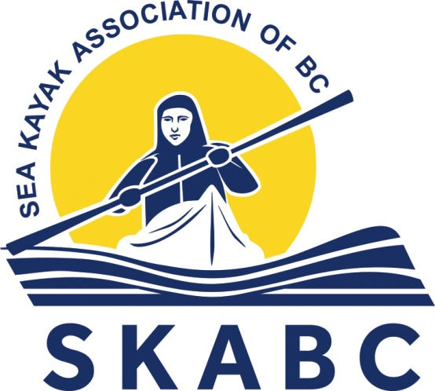

Social Media Guidelines

The Sea Kayak Association of BC (SKABC) Social Media Guidelines are intended to provide guidance for presenting and maintaining a professional Club profile online. This policy aims to establish a culture of openness, trust and integrity in all online activities related to SKABC.

SEA KAYAK ASSOCIATION OF BC (SKABC) SOCIAL MEDIA GUIDELINES
- Goals for Social Media 3
- Coverage 3
- Scope 4
- Principles 4
- Policy Breaches 5

1. SKABC GOALS FOR SOCIAL MEDIA
- Expand exposure of the Sea Kayak Association of BC (SKABC) to kayakers, potential new members, and the others in the paddling community.
- Disseminate information about events, meetings, trips etc. with consistent brand identity.
- Provide a platform for members to have their paddling & conservation media posted online (photos, videos etc.).
- To promote fellowship, safety, the exchange of information and skills, to encourage concern and respect for the environment, and to enhance public awareness of stewardship issues related to coastal sites and aquatic recreation.

2. COVERAGE
Authorization to post to the SKABC Social Media accounts is limited to those using Social Media as:
- Officially designated individuals tasked with posting content on Social Media; and
- A SKABC Executive posting content on Social Media.
Using Social Media in an official capacity: You must be authorized by the SKABC Executive before engaging in Social Media on behalf of SKABC.
In general, posts to SKABC Social Media accounts should be made by the Club Executive elected to that role. Posts can also be made by other Club Executives but should be coordinated to avoid duplication of content.
Posts (i.e. Comments, Likes, Sharing etc.) by anyone other than those officially authorized can be removed from SKABC Social Media without consent.
A professional demeanor, proper grammar, and clear and concise communications should always be maintained. The use of slang and profanity are not permitted.
All content should be posted across all accounts whenever possible/applicable in order to maintain consistency and relevance (i.e. when posting an item of content to Facebook, promptly post the same content to Twitter and Instagram, and if applicable, YouTube also). Social Media content management software is encouraged to facilitate this process.
Content posted to SKABC Social Media accounts should always include a reference to skabc.org (the main SKABC website). Content posted to the main website is exclusive of Social Media content. Content on the main website can however be shared on SKABC Social Media accounts when it's pertinent to do so.
All posts to SKABC Social Media accounts should be related to kayaking or conservation and of general interest to Club members and the paddling community at large. Posts should occur at minimum every two weeks to avoid inactivity and to maintain the interest of account followers & subscribers.
The SKABC Social Media accounts are generally not to be used for commercial purposes or to promote products and services that are unrelated to SKABC. Content related to SKABC vendors and sponsors may from time to time be relevant to post, like or share, but consensus from the Club Executive should be obtained before posting.

3. SCOPE
Social Media refers to any online tools or functions that allow people to communicate and/or share content via the Internet. This Social Media Policy applies to platforms including but not limited to:
- SKABC Website & Forums
- Facebook
- Twitter
- Instagram
- YouTube
- Any other online technologies that allow individual users to upload and share content.

4. PRINCIPLES
Use common sense
Whenever you are unsure as to whether or not the content you wish to share is appropriate, seek advice from others before doing so or refrain from sharing the content. When using Social Media, the lines between public and private, personal and professional, may be blurred. Remember, you are an ambassador for SKABC.
Protecting privacy
Be smart about protecting yourself and member privacy. When posting content online there is potential for that content to become publicly available through a variety of means, even if it was intended to be shared privately. Therefore, you should refrain from posting any content online that you would not be happy for anyone to see, even if you feel confident that a particular individual would never see it. Where possible privacy settings on Social Media platforms should be set to limit access. You should also be cautious about disclosing your personal details and others. Never post member addresses, email addresses, age, phone numbers etc.
Honesty
Your honesty or dishonesty may be quickly noticed in the Social Media environment. Do not post anything that is dishonest, untrue or misleading. If you are unsure, check the source and the facts before uploading or posting anything. SKABC recommends erring on the side of caution. If in doubt do not post or upload.
Do not post anonymously, using pseudonyms or false screen names. Be transparent and honest. Use your real name, be clear about who you are and identify any affiliations you have. If you have a vested interest in something you are discussing, point it out. If you make an endorsement or recommendation about something you are affiliated with, or have a close relationship with, you must disclose that affiliation.
The web is not anonymous. You should assume that all information posted online can be traced back to you. You are accountable for your actions both on and offline, including the information you post via the SKABC and your personal Social Media accounts.
When using Social Media you should be considerate to others and should not post information when you have been asked not to, or where consent has not been sought and given. You must also remove information about another person if that person asks you to do so. Permission should always be sought if the use or publication of information is not incidental, but directly related to an individual.
Gaining permission when publishing a person’s identifiable image
This is particularly relevant to publishing any information regarding minors. In such circumstances, parental or guardian consent is mandatory. You must obtain express permission from an individual to use a direct, clearly identifiable image of that person. You should also refrain from posting any information or photos of a sensitive nature. This could include accidents, incidents or controversial behaviour. Content provided to SKABC for use online is assumed to be submitted with permission as indicated in the Membership Agreement when joining SKABC.
Complying with applicable laws
Do not post or link to content that contains illegal or indecent material, including defamatory, vilifying or misleading and deceptive subject matter. It is also critical that you comply with all Copyright laws governing material owned by SKABC and others.
Discrimination, sexual harassment and bullying
The public in general, and SKABC members, reflect a diverse set of customs, values and points of view. You must not post any material that is offensive, harassing, discriminatory, embarrassing, intimidating, sexually explicit, bullying, hateful, racist, sexist or otherwise inappropriate.

5. POLICY BREACHES
If SKABC makes an error while posting on Social Media, be up front about the mistake, and address it quickly. If you choose to modify an earlier post make it clear that you have done so. If someone accuses SKABC of posting something improper (such as their copyrighted material or a defamatory comment about them), address it promptly and appropriately. In all cases such as these immediately inform the SKABC President and/or Executives.
Conscientious behaviour and awareness of the consequences
Keep in mind that what you write is your responsibility, and failure to abide by these guidelines could put your SKABC Membership at risk. Do not breach the terms and conditions for any third party sites in which you participate. If you disagree with or are unsure of the terms then do not proceed with a post to that site. Seek advice from the SKABC President and/or Executives.
The SKABC Executive reserves the right to suspend access and activity from any person officially designated to represent SKABC on Social Media, any Club Executive, Club Member or other persons with access to SKABC Social Media accounts.
All such persons agree that all usernames and passwords are the property of SKABC and cannot be changed without permission or withheld from SKABC.

